Project Report (Python)
Name- Kanav Sachdeva Teacher – Dr. Hanumat Sastry
Batch- 75 (Python Teacher)
SAP ID – 590022441

Health Diagnosis System Using Python

1. Abstract
The Health Diagnosis System is a software application developed using Python that helps in predicting possible diseases based on user-input symptoms. The system provides a simple graphical user interface (GUI) using Tkinter, processes medical data using Pandas and NumPy, stores patient records in SQlite3, and visualizes results using Matplotlib. This project aims to assist users in getting a preliminary understanding of their health condition quickly and efficiently.

2. Introduction
In today’s fast-paced world, access to quick and reliable healthcare advice is essential. Many people delay visiting doctors due to time constraints or lack of immediate access. This can lead to worsening of health conditions.
The Health Diagnosis System is designed to provide a basic and quick analysis of possible diseases based on symptoms entered by the user. While it does not replace professional medical advice, it acts as a preliminary diagnostic tool.
This system demonstrates how data analysis and visualization can be used in healthcare applications.

3. Problem Statement
Traditional diagnosis requires time, medical expertise, and physical presence. There is a need for a system that:
- Quickly analyzes symptoms
- Provides possible disease predictions
- Stores patient records
- Displays data visually for better understanding
The goal is to design a system that automates basic diagnosis using a dataset and provides user-friendly interaction.

4. System Design

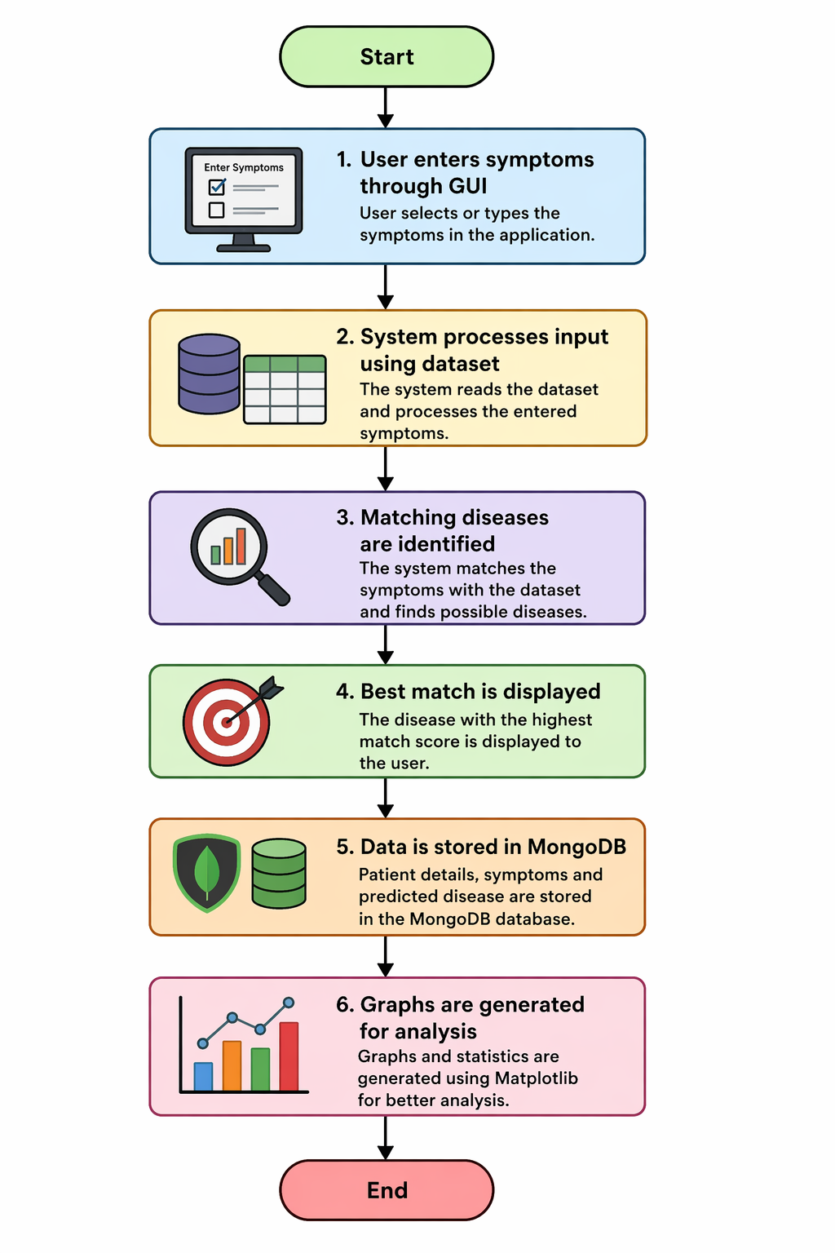
Flow of System:

5. Methodology
The system follows a structured approach:

Step 1: Input
- User enters symptoms using Tkinter GUI

Step 2: Data Processing
- Pandas is used to read and filter dataset
- NumPy is used to calculate matching scores

Step 3: Prediction
- Symptoms are compared with dataset
- Disease with highest match is selected

Step 4: Storage
- Patient data is stored in SQlite3 database

Step 5: Visualization
- Matplotlib is used to generate graphs such as:
  - Disease frequency
  - Patient statistics

6. Tools and Technologies Used
Tool | Purpose
Python | Core programming language
Tkinter | GUI development
Pandas | Data handling and filtering
NumPy | Calculations and logic
Matplotlib | Data visualization
SQlite3 | Database for storing records

7. Implementation
The project is divided into modules:

Frontend (GUI)
- Symptom input
- Buttons for prediction and graphs
- Output display

Backend Logic
- Dataset processing using Pandas
- Matching logic using NumPy

Database
- SQlite3 used for storing patient records
- Supports insert and retrieval operations

Visualization
- Graphs generated using Matplotlib

8. Results
The system successfully:
- Accepts user symptoms
- Predicts possible disease
- Stores patient data
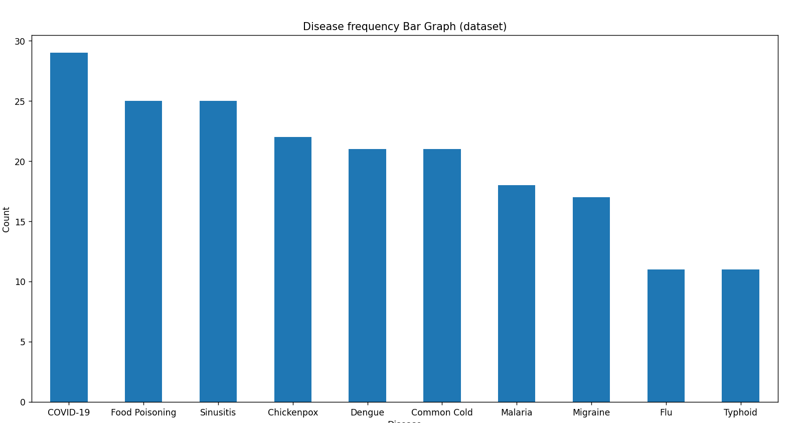
- Displays graphical analysis
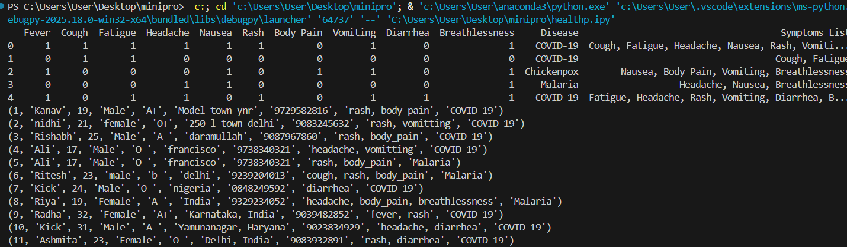
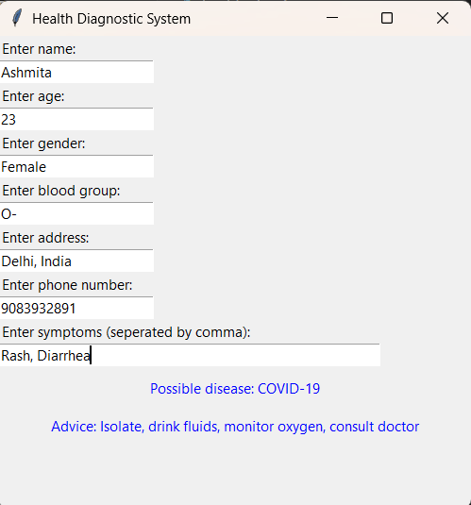

9. Advantages
- User-friendly interface
- Fast diagnosis
- Data storage capability
- Visual representation of data
- Easy to use

10. Limitations
- Not a substitute for professional medical advice
- Depends on dataset accuracy
- Limited to predefined symptoms

11. Conclusion
The Health Diagnosis System demonstrates how Python libraries can be integrated to build a real-world application. It simplifies the process of identifying possible diseases based on symptoms and provides quick insights. The project successfully combines GUI, database, and data analysis into a single system.

12. Future Scope
- Integration with Machine Learning models for better accuracy
- Mobile application development
- Voice-based symptom input
- Online doctor consultation feature
- Larger and more accurate datasets

